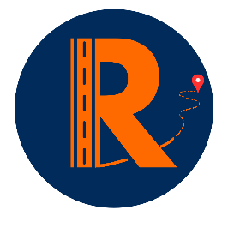
RoadReach UK Brand Pricing
Thank you for your interest in RoadReach UK. Below is our pricing structure for advertising your brand through our driver network.

Pricing Plans (Per Driver)
Monthly Plan
- Standard Cost: £60 per month
- Billing: Monthly Payments (every 30 days)
- Flexibility: Cancel anytime (charges may apply)
- Dynamic QR code within Design: £5 single charge
Phase 1 Pricing (Limited Time, Limited Availability)
- Cost: £40 per month with any plan
- Availability: Limited spaces & available until Phase 1 ends
- Dynamic QR Code: Free of Charge

What’s Included in your plan?
- Access to a network of vetted drivers
- Flexible campaign durations
- Free Custom branding on driver vehicles
- Monthly campaign reports
- Dedicated support
- Option for Free Business showcase on Website and Community page.

Next Steps
To proceed, please complete the detailed application form provided. Once submitted, our team will review and apply your brand to our RoadReach catalogue for drivers to see right away.
Need more information? Contact us at
info@roadreachuk.com

